2020

Office Workshop Showroom & Send-in Address
PLEASE COPY THIS ADDRESS IN ITS FULL
F.A.O. Nigel Eastwood
Wax Jackets Cleaned / Wax Jackets UK LTD
C/O CYKO Ltd,
5A / 5B Marcliffe Industrial Estate,
Macclesfield Rd,
Hazel Grove, Stockport SK7 5EG
United Kingdom
Office / Workshop / Showroom: 0161 484 2002 (24hr answerphone)
Email address: waxit@waxjacketscleaned.co.uk
www.waxjacketscleaned.co.uk / www.waxjacketscleaned.com
Office Workshop Showroom Opening Hours:
Monday to Friday: 9am-5pm
CLOSED WEEKENDS (UNTIL FUTHER NOTICE)
Please feel free to call in at our workshop / office and drop-off your WAXED GARMENT
(BUT PLEASE PHONE IN ADVANCE TO CLARIFY WE ARE OPEN!!!). If this is what you choose to do PLEASE FILL IN AND BRING THE OWNER SEND IN FORM WITH YOU!

Cleaning & Re-Waxing Price 2020 (excluding P & P)
We have a very strict policy on > NO REPAIR ONLY – NO CLEAN ONLY – NO WAX ONLY

Clean & Re-Wax (All sizes up to & including L (large) 40” Including women’s sizes up to and including 16)
Bomber Jacket £50.00 Jacket up to 32” (length) £55.00
Jacket / Coat above 32” (length) £60.00
Long Coat / Riding / Stockman Coat £66.00
Trousers £45.00 Gilet £45.00 Hat £15.00
Extras: Belt £3.50 - Hood £5.00
Shoulder Guard / Neck Cover £5.00 + any % for Size.
Extra Charges: - XL 42/44” + 10% 2XL 46/48” + 15% 3XL + 20%

Excessive / Very Dirty Jackets or Trousers Plus removal of Excessive Wax (Extra £8.00 per item will be charged)

PLEASE NOTE THAT THE ABOVE PRICES ARE IN BRITISH POUNDS BECAUSE THERE ARE TOO MANY RATES / CONVERSIONS TO ACCOUNT FOR.

PLEASE CONVERT YOUR TOTAL COST FOR THE WORKS DONE ON THE DAY OF PAYMENT, NOT BEFORE, AS YOU MAY END UP WITH AN INACCURATE REPRESENTATION OF THE PRICE.

‘Important Information about
the Wax Finishes / Dressings Available’

Silk-oil Wax Finish (WAX 2) – EXTRA charge of £5.00 + any % for size
This finish is the most popular, does have little sticky finish / touch, but this does settle down after a few weeks and is ideal for more outdoor use, it gives a very good water-resistant finish. This wax is supplied direct from a UK manufacturer of waxed cotton fabric and regularly used.

Heavy Wax Finish (WAX 3) - EXTRA charge of £10.00 + any % for size
This finish can be very sticky and has an oily touch; this will give as close to WATER-PROOF (but not Guaranteed) that’s possible, not advisable to be worn as other than OUTDOOR clothing, ideal for Riding Coats and full-length Stockman’s where not used for casual / fashion use.

Basic / Fashion Wax Finish (WAX 1)
This is a basic wax dressing and has little or no sticky oily touch finish, ideal for the modern wax cotton Jacket / Garment getting increasingly popular.

“Please allow 6 weeks from when WjC
receive your items”

Cleaning, Re-Waxing & Full Restoration Service

We Clean, Re-Wax and Repair ‘ALL’ (Vintage or Modern)
Motorbike, Country & Fashion, Any Colour or Size of
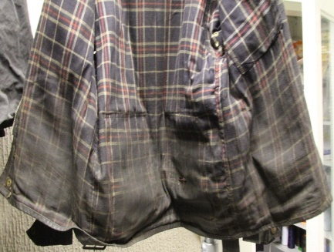
Wax Cotton Jackets & Trousers
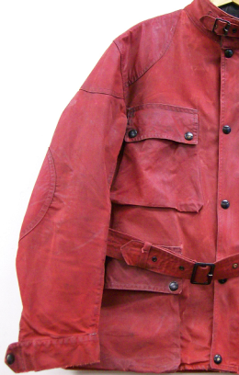
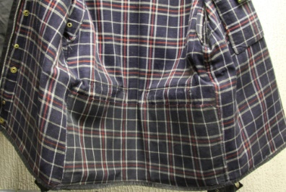
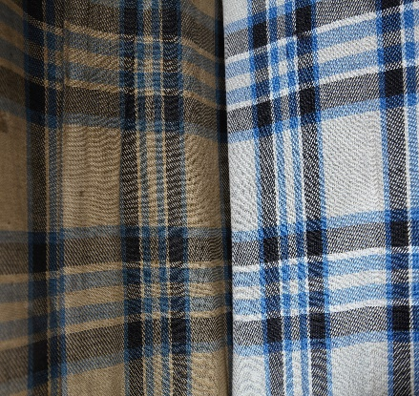
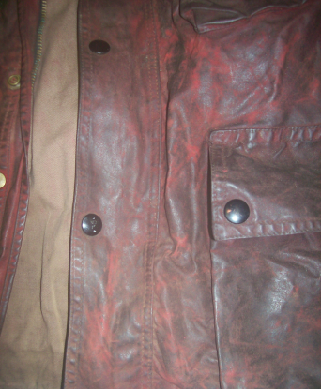

After
Before

This is what can be achieved with our unique cleaning process and
will remove up to 99% of any bad smells associated with wax cotton garments, ‘Yes’ these are the same jackets.
IMPORTANT INFORMATION:
We do not and will not guarantee that all stains can be removed, there are limitations with the gentle cleaning process but we endeavour to achieve the best result possible without damaging the garment, most come clean, but it will be clean and most important ‘FULLY WEARABLE’ again.
We carry out a full and comprehensive repair, alteration and modification service to all
Wax Cotton Garments.

PRIOR TO YOU SHIPPING YOUR GARMENT, IT IS IMPERITIVE THAT YOU MAKE CONTACT WITH US BEFOREHAND! WE HAVE A CONCISE LIST OF INSTRUCTIONS TO MAKE SURE THAT YOU ARE NOT HIT WITH AN UNEXPECTED TAX BILL FROM THE UK GOVERNMENT! KEEP READING TO FIND THEM OUT, OR CHECK ON OUR WEBSITE!

PLEASE NOTE: we DO NOT give estimates or quotations over the telephone, we only quote once we have seen the garment, if you want to send some pictures, we can hopefully give a rough estimate for the works, please email us –
waxit@waxjacketscleaned.co.uk
MINIMUM CHARGE FOR REPAIRS
£10.00

We DO NOT Guarantee that your Jacket or Trousers Waterproof or 100% Waterproof
But please say how you will use the jacket as we will then endeavour to get as close as possible. NO ‘new’ WAXED COTTON IS GUARANTEED 100%WATER-PROOF
All waxed cotton garments will change colour. Some slightly, some dramatically meaning that the fabric will be darker than before. Wax dressing is a Neutral colour and has no dyes, special finishes on modern Wax Cotton Garments can never be replicated.
Wax Jackets are an outdoor item of clothing, after the Cleaning & Re-waxing it is advisable NOT to wear indoors and in Motor Vehicles as the wax dressing will transfer on to other fabrics. After the process some have a more of a stickier finish than others, please see above for more details, but this will settle down after a sort time of wearing. Your item will ‘NOT’ come back NEW it will be returned Cleaned and Professionally Re-Waxed by hand. Cleaned means we will get it as clean as possible, it is a gentle cleaning process so there are limitations, in 95% + of cases we get them perfectly clean, some stains may still be visible!!
But the garment will be clean and more importantly fully wearable.
Return Postal & Packaging Costs

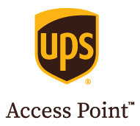
"Price on application"

THIS IS ALSO A MAXIMUM COST TO USE THIS SERVICE, WHICH IS FULLY TRACKED!

The costs for shipment are roughly £55 returned back to the access point of your choosing, based on (but not limited to) the following:

The parcel is using a small, plastic postal bag which has been wrapped and packed as tightly as possible (so if you can fold and wrap the garment, then insert into a bag),
The parcel weighs less than 3kg,
You do not want to insure your garment

Important Information
ADD YOUR OWN ADDRESS AS A RETURN LABEL / RETURN ADDRESS, AS WE HAVE HAD MANY ITEMS SENT TO US WITH NO INFORMATION WHATSOEVER, MEANING WE DO NOT KNOW WHO SENT THE JACKET, WHERE THE JACKET CAME FROM ETC. IT IS IMPERATIVE THAT CONTACT INFORMATION IS INCLUDED!!!

Please send your Garments via a signed - for service.
(Royal Mail Signed for service is ample)
We must be able to sign for the Garment/s at our shop.
(No signature!! NO proof of Delivery)
We can’t be responsible for garments lost in post.
CHECK ALL POCKETS BEFORE SENDING

ALL Wax Jackets SAY
*DO NOT* *DO NOT* *DO NOT*
Most manufactures would prefer you to buy a NEW one that definitely includes Belstaff & Barbour, that’s not very eco-friendly and cost effective but here at WjC we have the solution!

In sending your garment/s for Cleaning / Repair / Alteration & Re-waxing, you are giving authority for Wax Jackets Cleaned to complete the necessary works and
agree to all WjC Terms & Conditions

